**SPH3U 6.4 States of Matter and Changes of State**

1. **Changes of state**

|  |  |  |
| --- | --- | --- |
| Fusion: | Vaporization: | Sublimation: |
| Condensation: | Freezing: |

1. **Heating and cooling graphs**

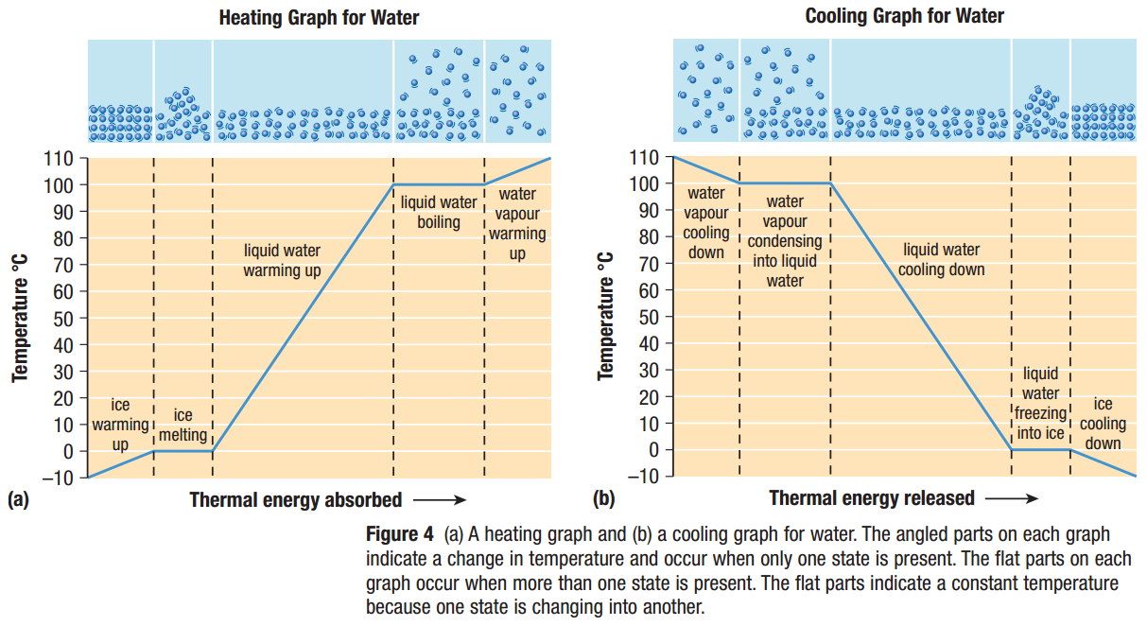

1. **Latent heat**

|  |  |
| --- | --- |
| Latent heat: |  |
| specific latent heat |  |

|  |  |  |  |  |
| --- | --- | --- | --- | --- |
| **Substance** | **Specific latent heat of fusion, Lf (J/kg)** | **Melting point (°C)** | **Specific latent heat of vaporization, Lv (J/kg)** | **Boiling point (°C)** |
| aluminum | 6.6 x 105 | 2519 | 4.0 x 105 | 10900 |
| ethyl alcohol | 1.1 x 105 | –114 | 8.6 x 105 | 78.3 |
| carbon dioxide | 1.8 x 105 | –78 | 5.7 x 105 | –57 |
| gold | 1.1 x 106 | 1064 | 6.4 x 104 | 2856 |
| lead | 2.5 x 104 | 327.5 | 8.7 x 105 | 1750 |
| water | 3.4 x 105 | 0 | 2.3 x 106 | 100 |

|  |  |  |
| --- | --- | --- |
| Latent heat during a change of state: | Melt/freeze: | Boil/condense: |

How much thermal energy is released by 652 g of molten lead when it changes into a solid?

Ethyl alcohol is a liquid at room temperature. How much thermal energy is absorbed when 135 g of ethyl alcohol at 21.5 °C is heated until all of it boils and turns into vapour?

1. **Water: A special liquid**

|  |  |
| --- | --- |
| Most solids: |  |
| solid water |  |
| water molecule shape |  |

**Homework:** page 295: #1-2, 5, 7